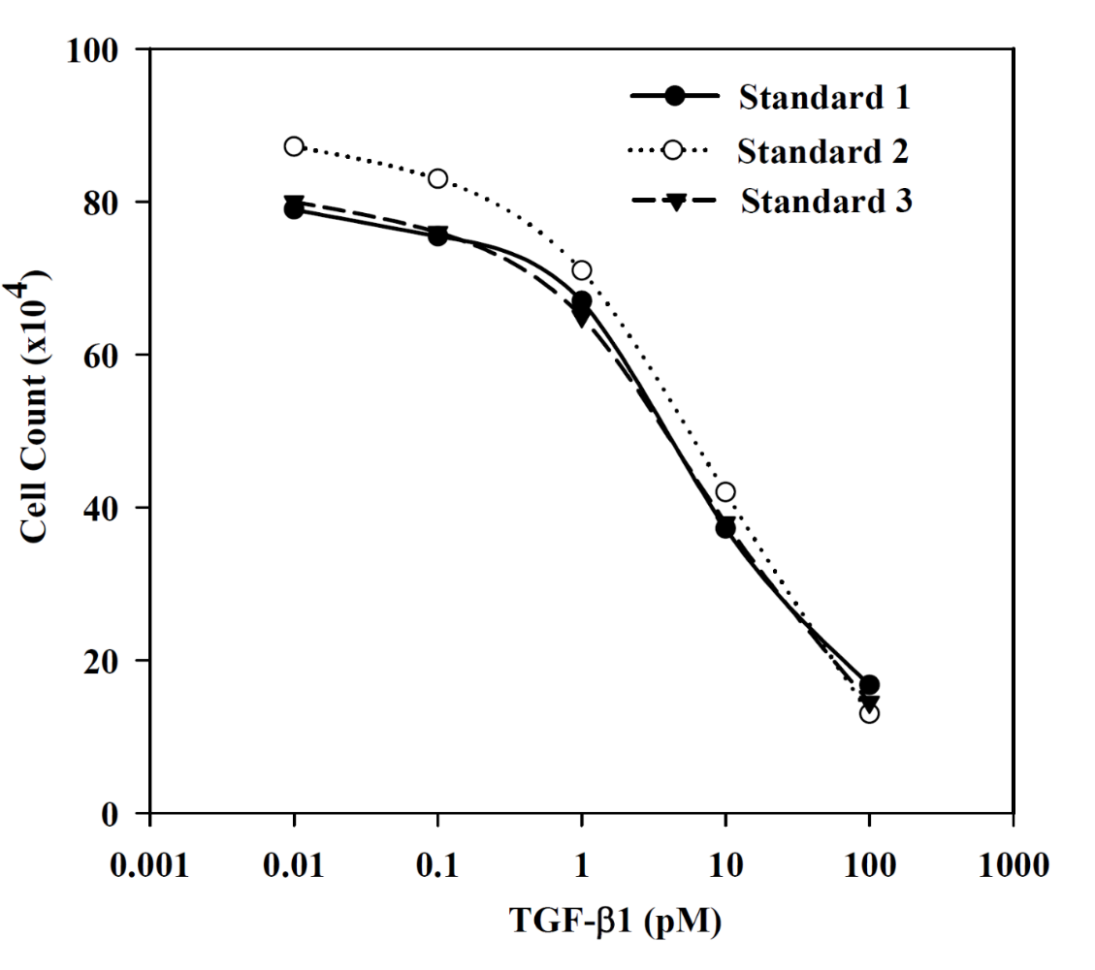

Figure S1. Shown are the standard curves to quantitate active TGFβ1.
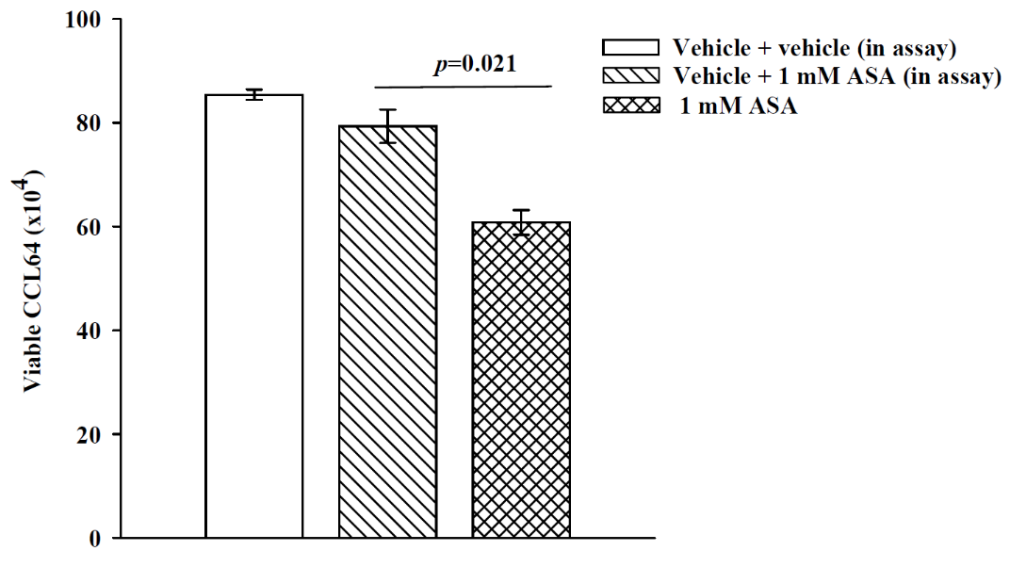

Figure S2. The cell counts are shown for the TGFβ1 bioassay. Vehicle represents what was added to the P-MSCs, media from these cultures when tested in the bioassay, contained additional vehicle; Vehicle + ASA indicated that ASA was added to the bioassay to ensure that residual ASA in the treated cultures did not alter CCL64 viability.

