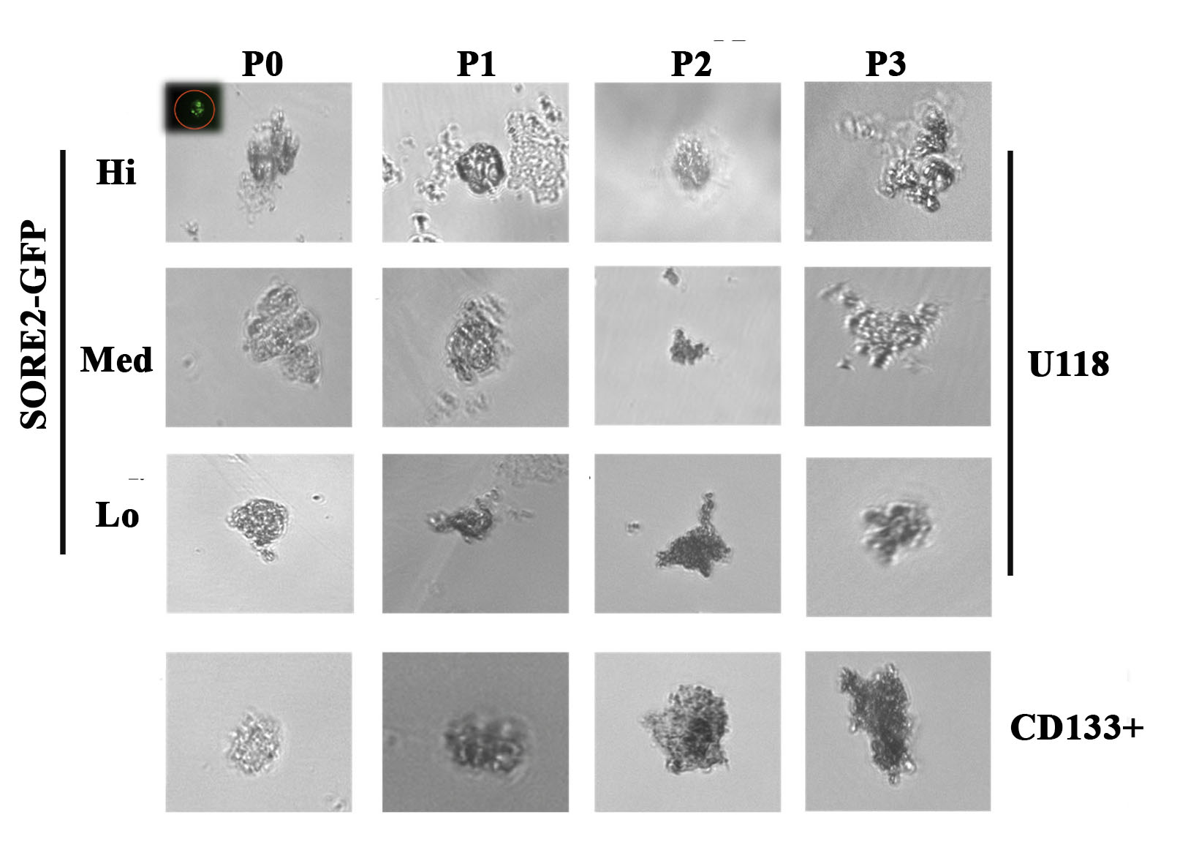
Figure S1. Shown are representative spheres from SORE6-GFP-U118 sorted Oct4a hi, med and lo cells. Spheres are shown up to passage 3. Also shown are spheres from CD133+ cells sorted from SORE6-GFP U118 GBM cells.

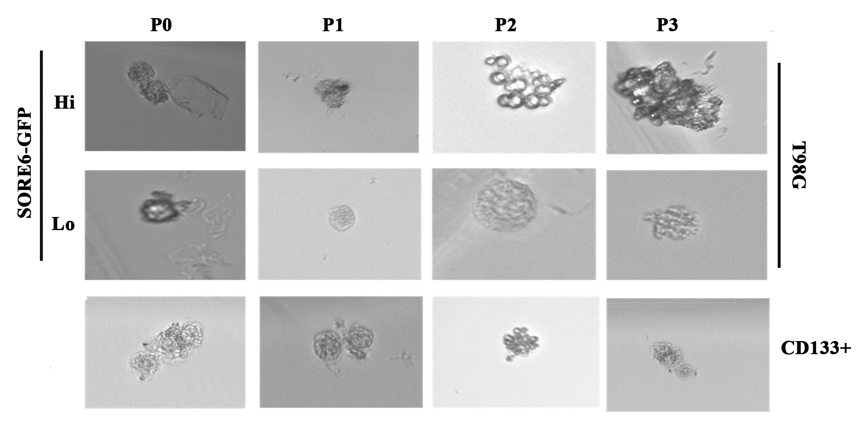
Figure S2. Shown are representative spheres from SORE6-GFP-T98G cells, used to sort Oct4a hi, med and lo cells. Spheres are shown up to passage 3. Also shown are spheres from CD133+ cells sorted from SORE6-GFP T98G cells.

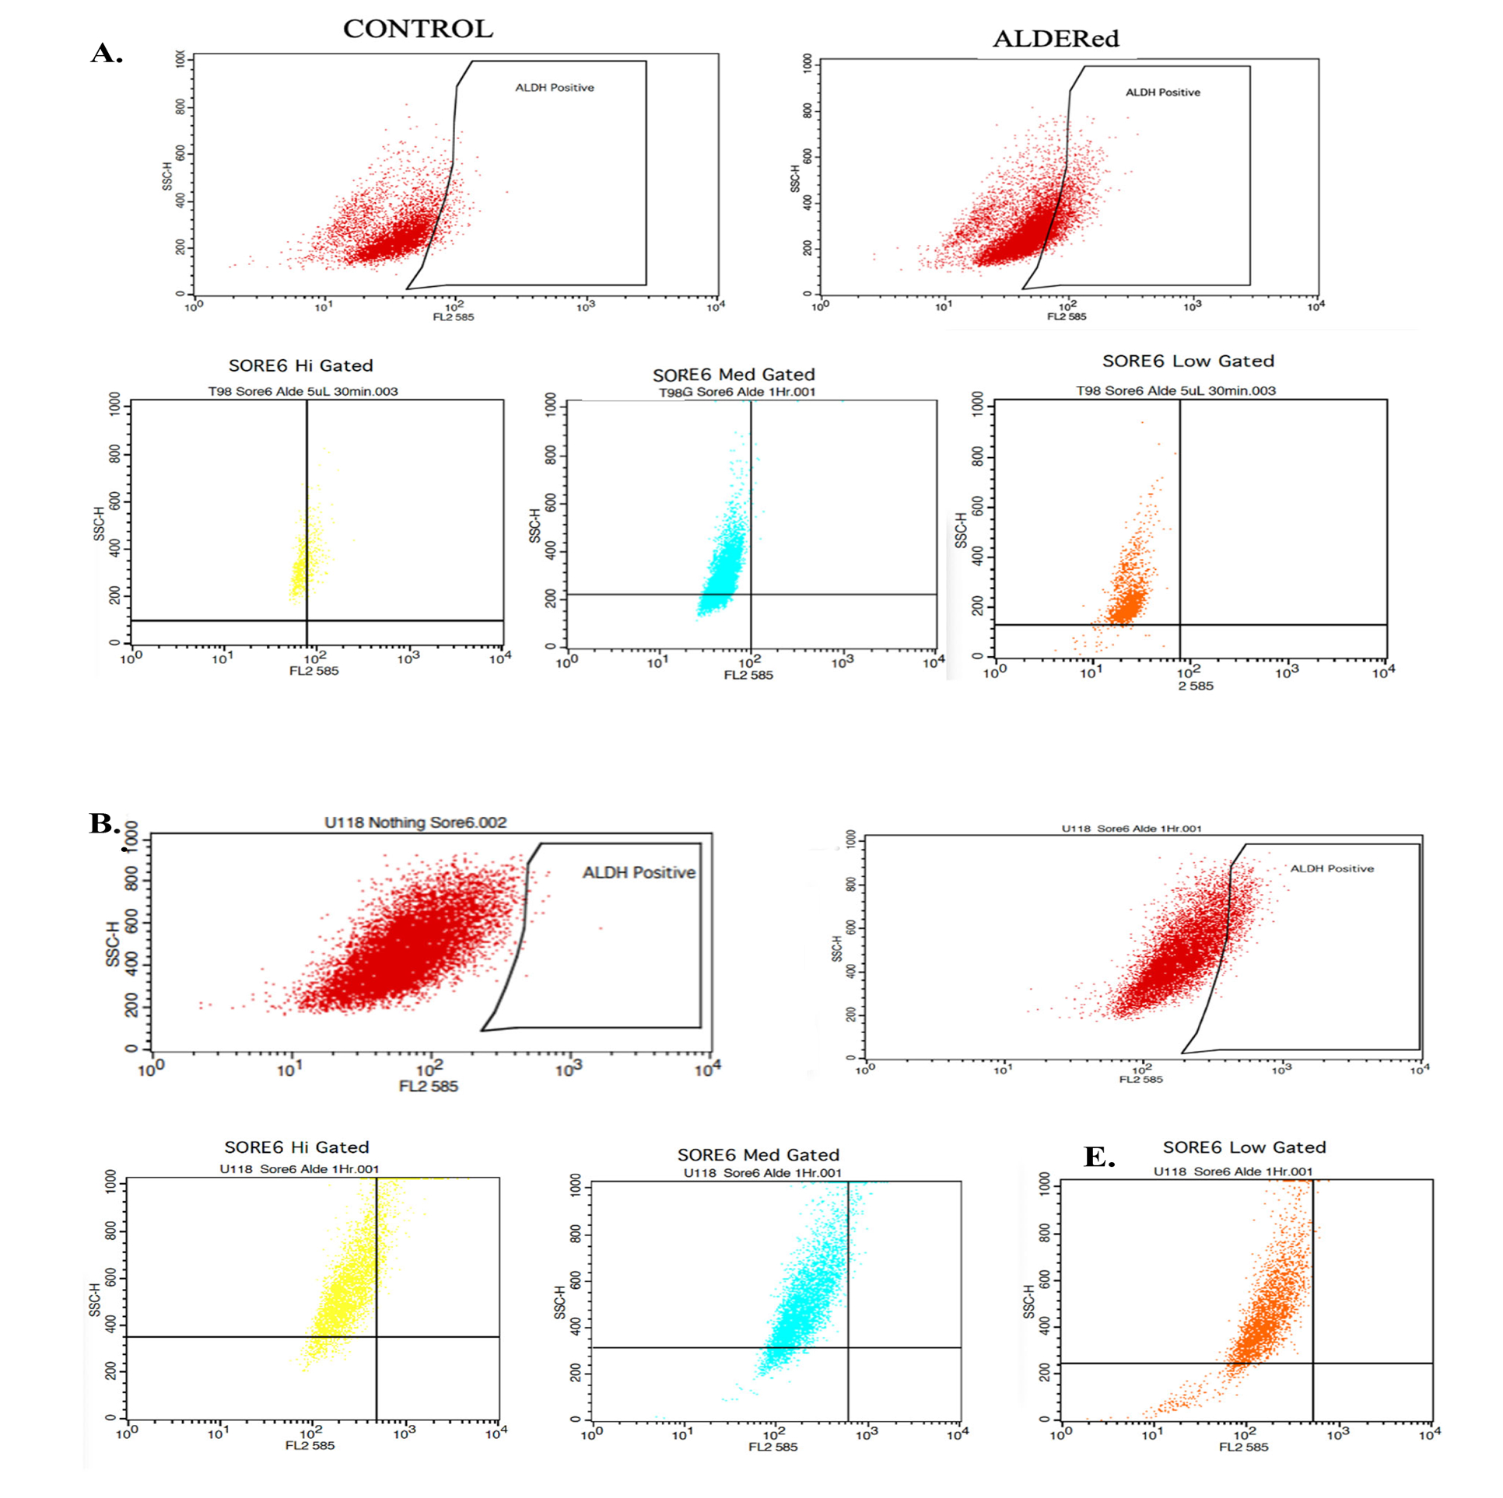
Figure S3. ALDH assay with subsets of U118 or T98G-SORE6-GFP. U118 cells (A) or T98G (B) were analyzed for ALDH. Shown are representative plots for unstained/negative control, AldERED stained ALDH positive cells, and ALDH positive cells in Hi, med and lo SORE6-GFP subsets.

