**Electronic Supplementary File**

**MXeneCeria Composite Heterostructure: Stable Integration of Ti3C2Tx Nanosheet-derived Quantum Dots into Fluorescent Nano-octahedral CeO2**

Alireza Rafieerada,b, Soofia Khanahmadib, Sanjiv Dhingraa,*

*a Institute of Cardiovascular Sciences, St. Boniface Hospital Albrechtsen Research Centre, Department of Physiology and Pathophysiology, Max Rady College of Medicine, Rady Faculty of Health Sciences, Biomedical Engineering Program, University of Manitoba, Winnipeg, Manitoba R2H 2A6, Canada*

*b Institute for Molecular Biosciences, Johann Wolfgang Goethe University Frankfurt am Main, 60438, Frankfurt, Germany*

***Contents:***

Supplementary Figures S1 to S6, and Tables S1 to S6 (eight pages)

**\**Correspondence:***

Sanjiv Dhingra, PhD, FAHA, FIACS, FAPS

Director: Canada-Italy Tissue Engineering Program

R-3028-2, Institute of Cardiovascular Sciences

St. Boniface Albrechtsen Research Centre, University of Manitoba

351 Tache Avenue, Winnipeg, R2H2A6, Canada.

E-mail address: [sdhingra@sbrc.ca](mailto:sdhingra@sbrc.ca) / [sanjiv.dhingra@umanitoba.ca](mailto:sanjiv.dhingra@umanitoba.ca)

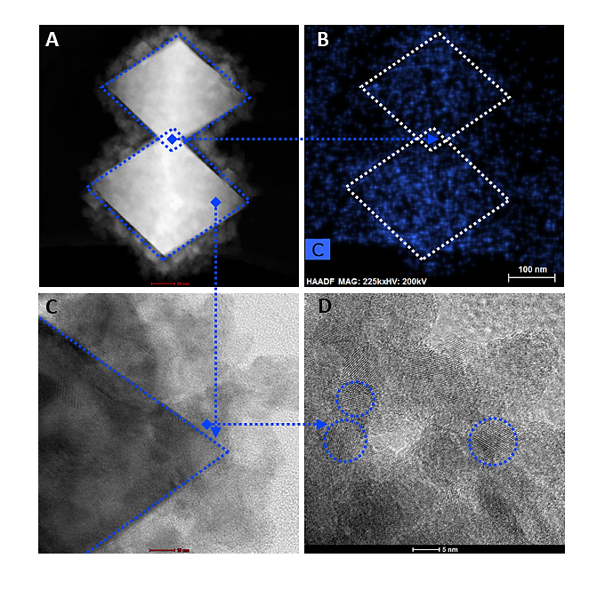

**Supplementary Figure S1:** A, B: Scanning TEM image and corresponding EDX carbon mapping. C, D: High-resolution TEM images of MXeneCeria, depicting the successful synthesis and integration of Ti3C2Tx MXene quantum dots into CeO2 nanoparticles.

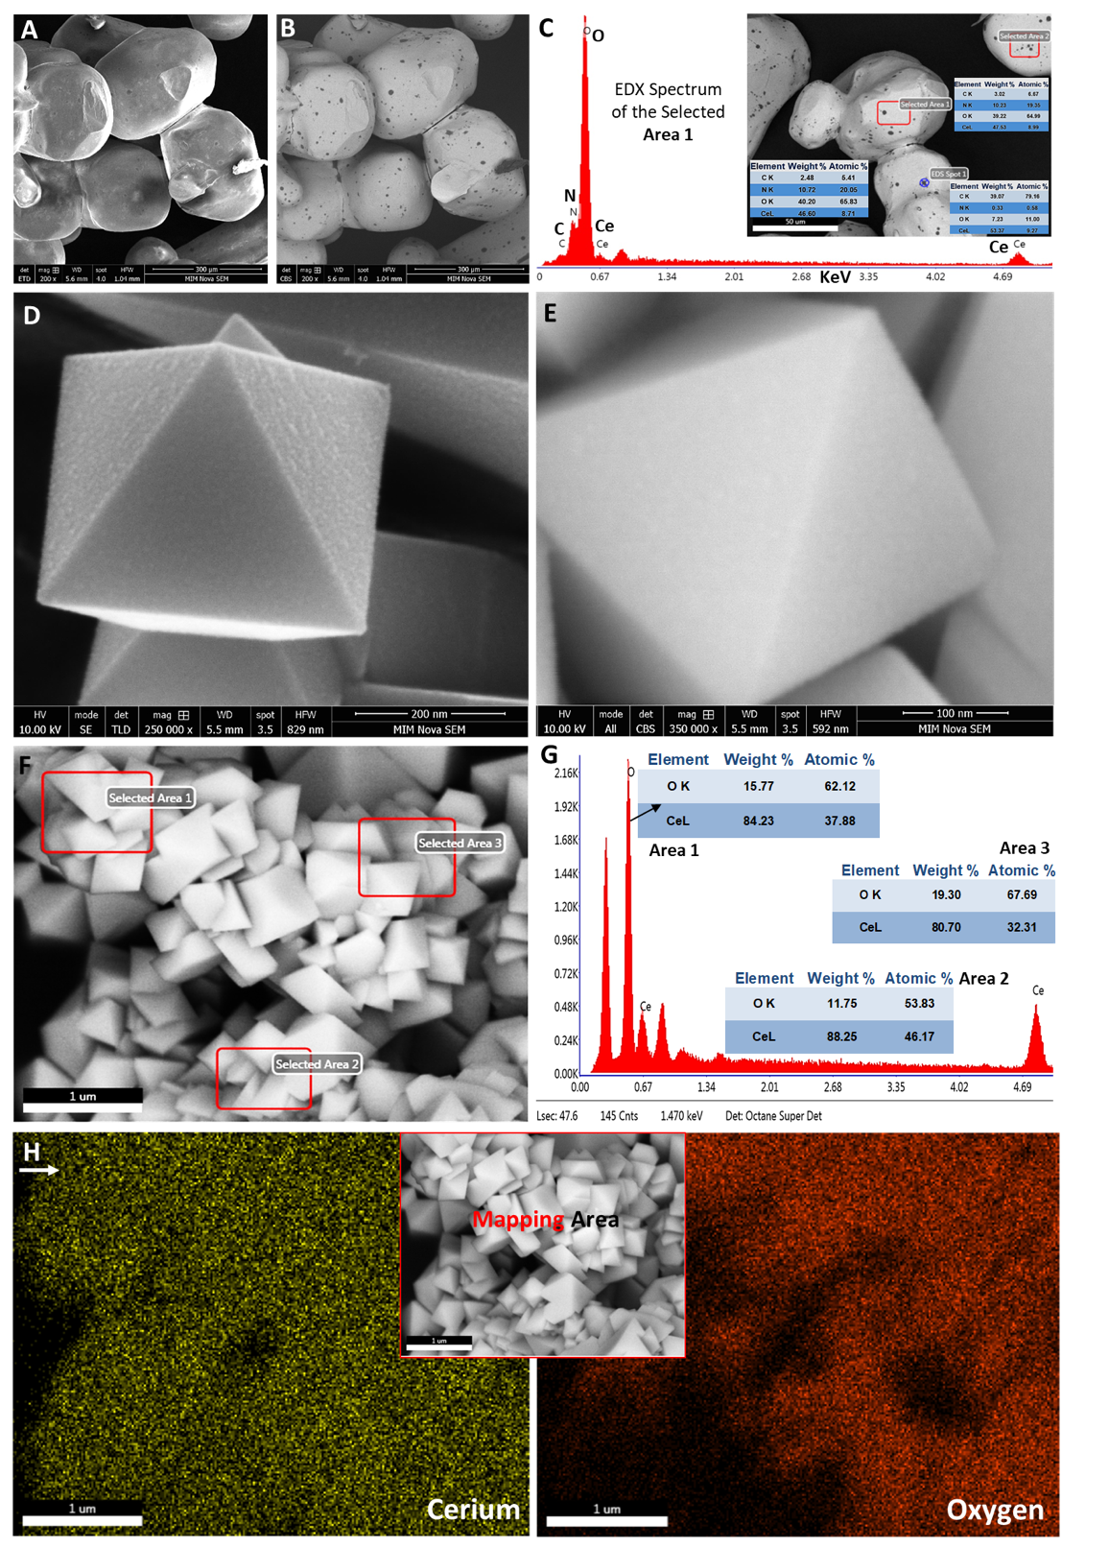

**Supplementary Figure S2:** A–G:SEM (SE and CBS modes) images and corresponding EDX area scan analysis as well as weight and atomic percentage quantification of bulk cerium(III) nitrate hexahydrate powder and CeO2 . H: EDX mapping of these nanoparticles associated with the cerium and oxygen elements.

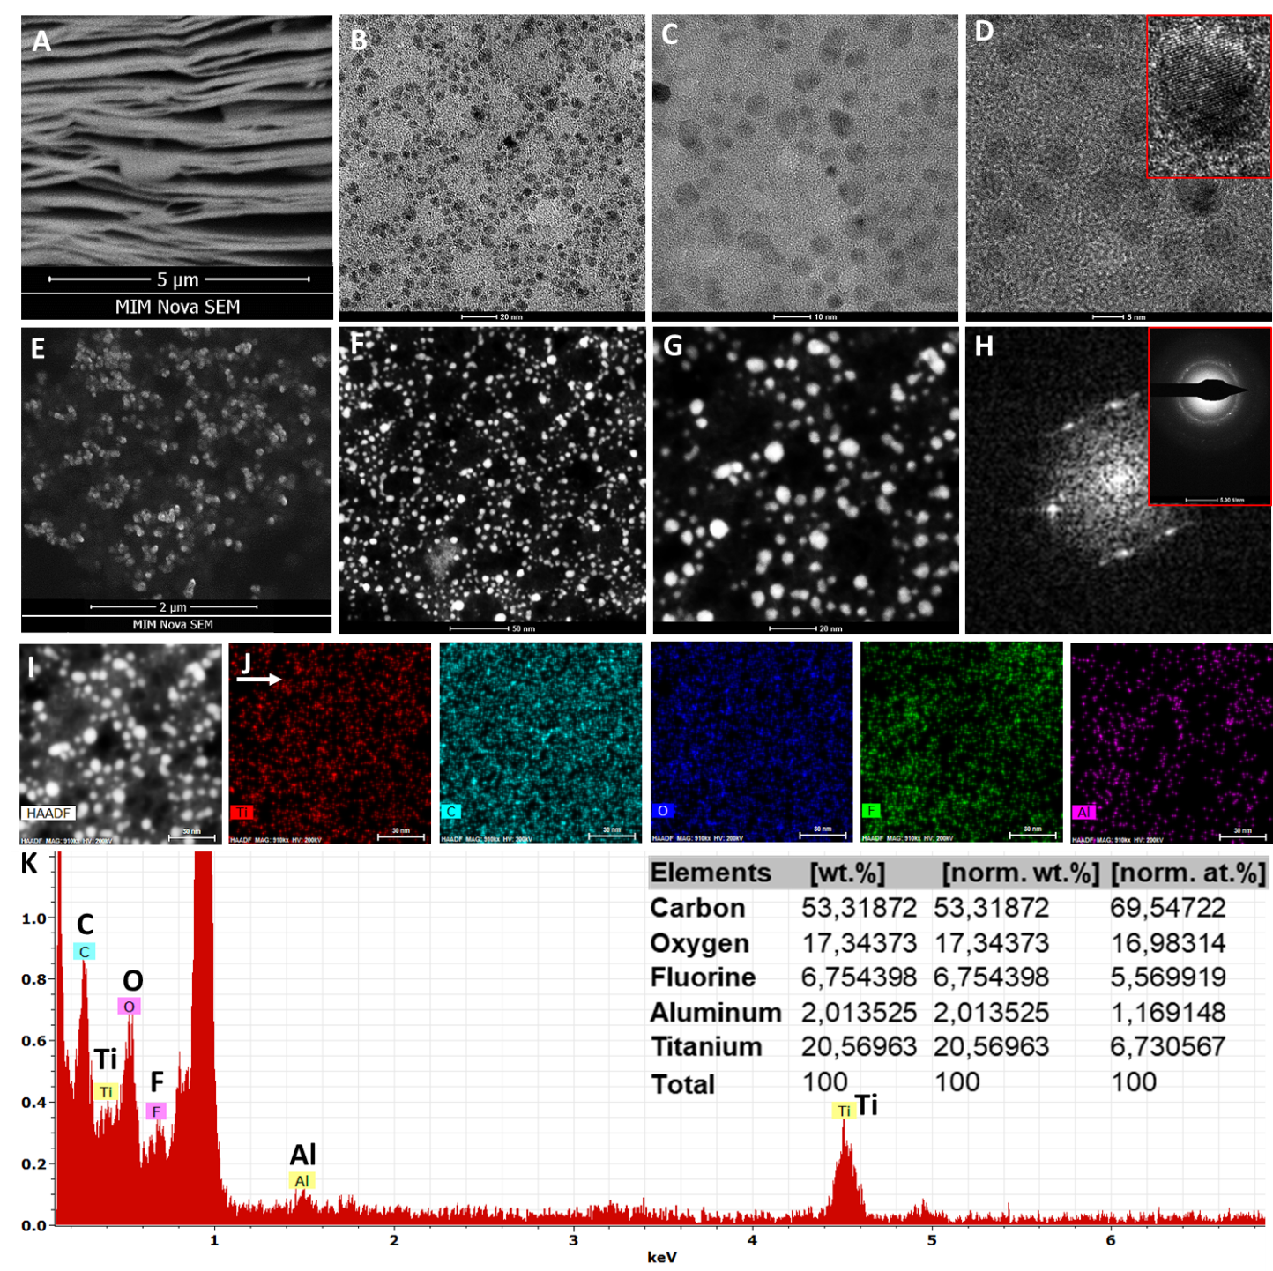 **Supplementary Figure S3:** A:SEM analysis of Ti3C2Tx MXene nanosheets. B, C: TEM. D: High-resolution TEM images of the as-synthesized Ti3C2Tx MXene quantum dots, the analysis shows the presence of stable surface titanium oxides. E: SEM. F, G: Scanning-TEM images. H, inset: FFT and SAED patterns. I: HADAF image. J: EDX elemental mapping. K: Area scan analysis of MXene quantum dots. Together, these data confirm the successful conversion of Ti3C2Tx nanosheets to quantum dots with an average diameter of less than 10 nm. These data also confirm the negligible presence of aluminum in MXene quantum dots.

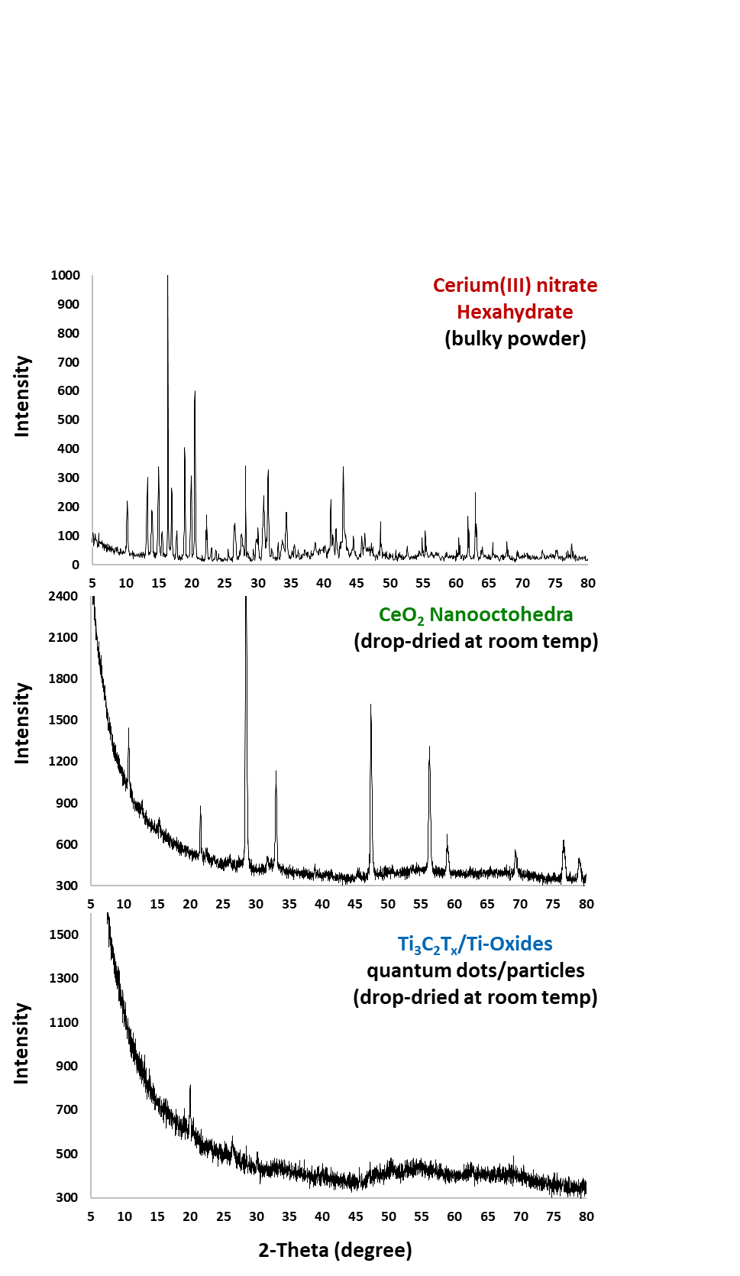

**Supplementary Figure S4:** XRD phase pattern of cerium(III) nitrate hexahydrate powder, the derived nano-octohedral cerium oxide particles, and as-synthesized Ti3C2Tx MXene quantum dots.

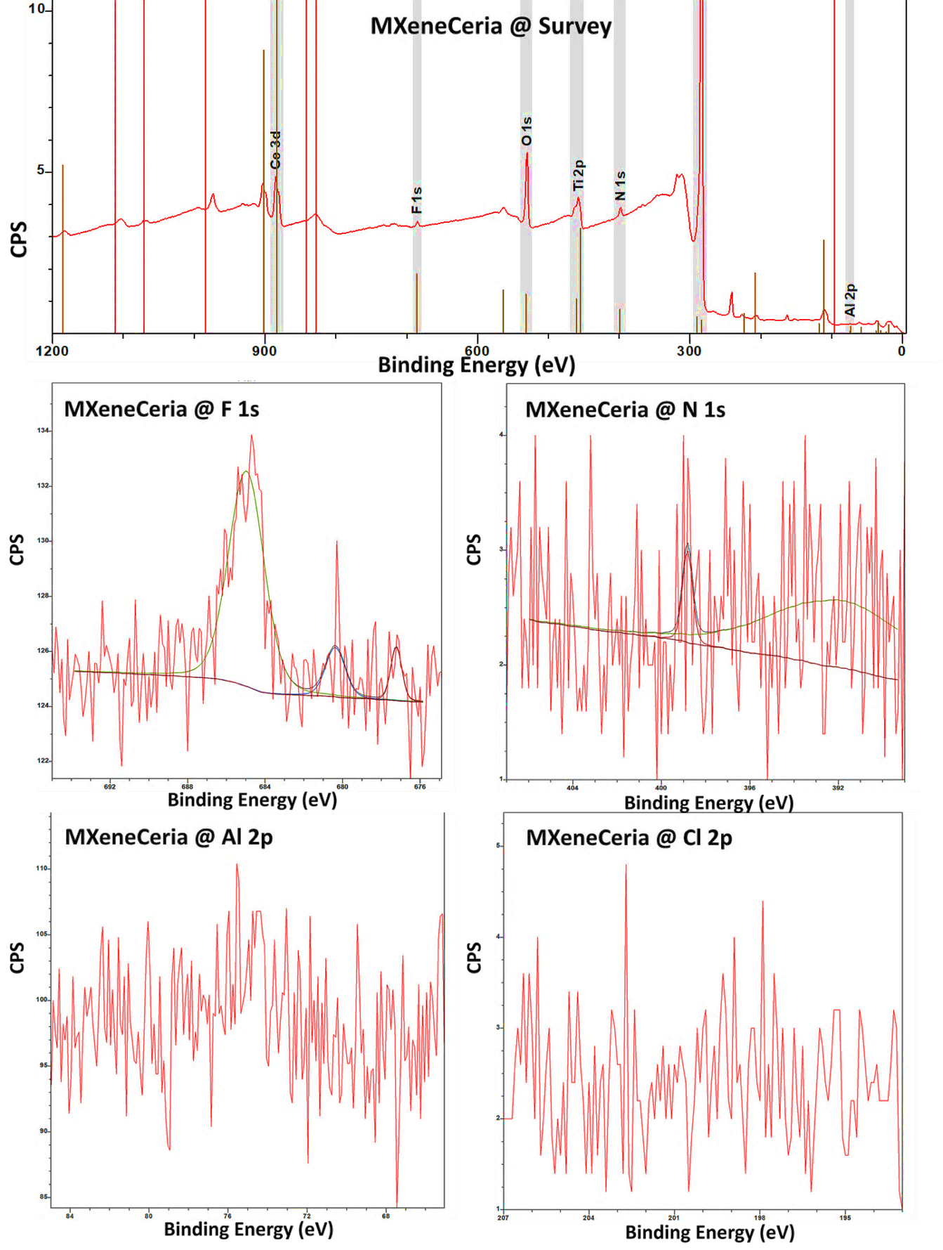

**Supplementary Figure S5:** XPS analysis of MXeneCeria and corresponding narrow fitting of F 1s, N 1s, Al 2p, and Cl 2p. These data confirm the negligible presence of aluminum in the surface composition of MXeneCeria. There were no traces of chlorine found in XPS analysis, confirming the data obtained from EDX/XRD analysis of the material.

**Supplementary Table S1:** XPS fitting analysis of Ce 3d associated with MXeneCeria colloids.

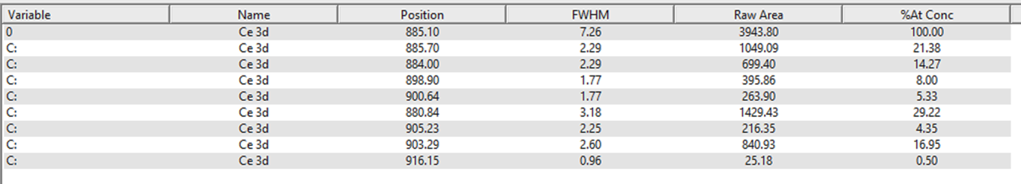

**Supplementary Table S2:** XPS fitting analysis of Ti 2p associated with MXeneCeria colloids.

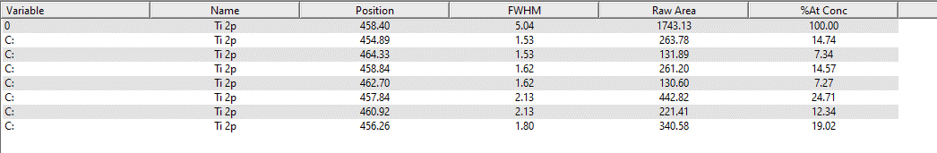

**Supplementary Table S3:** XPS fitting analysis of C 1s associated with MXeneCeria colloids.

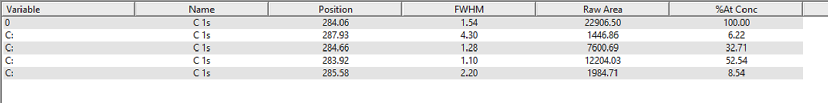

**Supplementary Table S4:** XPS fitting analysis of O 1s associated with MXeneCeria colloids.

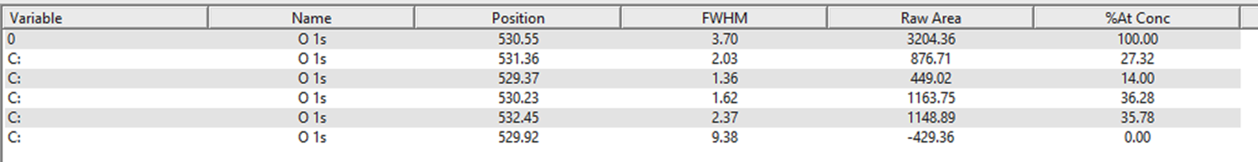

**Supplementary Table S5:** XPS fitting analysis of F 1s associated with MXeneCeria colloids.



**Supplementary Table S6:** XPS fitting analysis of N 1s associated with MXeneCeria colloids.



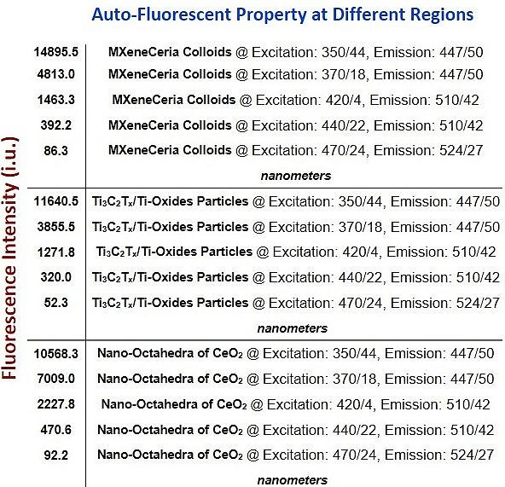

**Supplementary Figure S6:** Measurement of auto-fluorescenceof Ti3C2Tx MXene quantum dots, CeO2 nanoparticles, and MXeneCeria at different excitation/emission wavelengths.

**Supplementary Reference**

1. Li, Ping, Yong Zhou, Zongyan Zhao, Qinfeng Xu, Xiaoyong Wang, Min Xiao, and Zhigang Zou. "Hexahedron prism-anchored octahedronal CeO2: crystal facet-based homojunction promoting efficient solar fuel synthesis." *Journal of the American Chemical Society* 137, no. 30 (2015): 9547-9550.

<https://doi.org/10.1021/jacs.5b05926>